|  |  |
| --- | --- |
| **Name:** | Lucy |
| **Age:** | 1 |
| **Breed:** | Labrador |
| **Size:** | Medium - Large |
| **Colour:** | Black |
| **Personality:** | Energetic and friendly. |
| **Description:** | Lucy is a young friendly dog who loves meeting new people. Some further training is needed however, she has mastered some basic skills and has plenty of potential. |

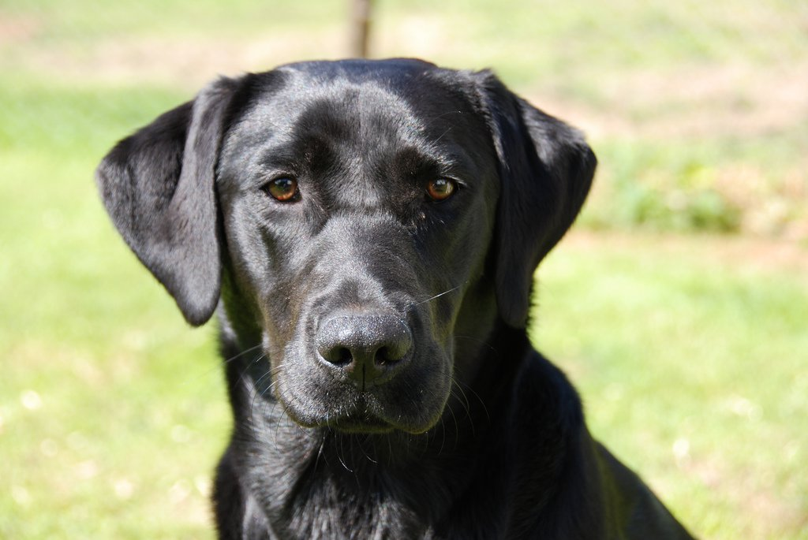

|  |  |
| --- | --- |
| **Name:** | Benny |
| **Age:** | 5 |
| **Breed:** | Husky |
| **Size:** | Large |
| **Colour:** | Black and white |
| **Personality:** | Friendly and playful. |
| **Description:** | Benny is a very friendly, well behaved dog. He is fully trained and is just looking for a new loving owner. |

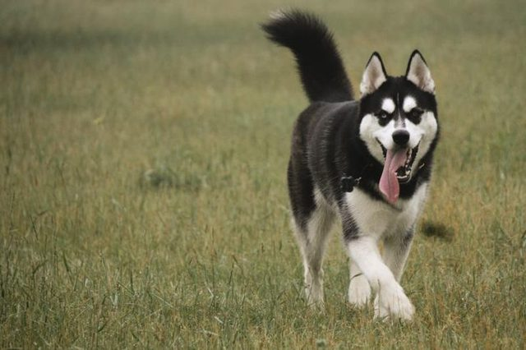

|  |  |
| --- | --- |
| **Name:** | Jake |
| **Age:** | 2 |
| **Breed:** | Beagle |
| **Size:** | Small – Medium |
| **Colour:** | Black, brown and white. |
| **Personality:** | Shy and quiet. |
| **Description:** | Jake is a very friendly, well behaved dog. He takes a while to warm up to new people however, when he does he is very obedient. |

